# Ex no: 7

DEVELOP A SIMPLE EMAIL AUTOMATION SERVICE USING SALESFORCE

# Aim:

To develop a simple email automation service using salesforce.

# Procedure:

1. Create a Salesforce account.
2. Click on the settings icon on the top right corner of the home page and open the advanced setup page.
3. Search for flow in the search bar and click on Flows in Process Automation.
4. Create a new flow and select the flow type as Record-Triggered Flow to start an automation when a record is created or triggered.
5. Select the Object you want to trigger the flow (example: Lead).
6. Configure the trigger so that the flow will start when a record is created.
7. Now set the condition that triggers the email i.e when the lead’s status is set to “Qualified”.
8. In the flow builder click on + to add an element and select Action from the interaction menu.
9. In the Action type search for send email and you need to configure the recipient address list, recipient email id and the sender’s email address.
10. Save and activate the flow.

# Output:

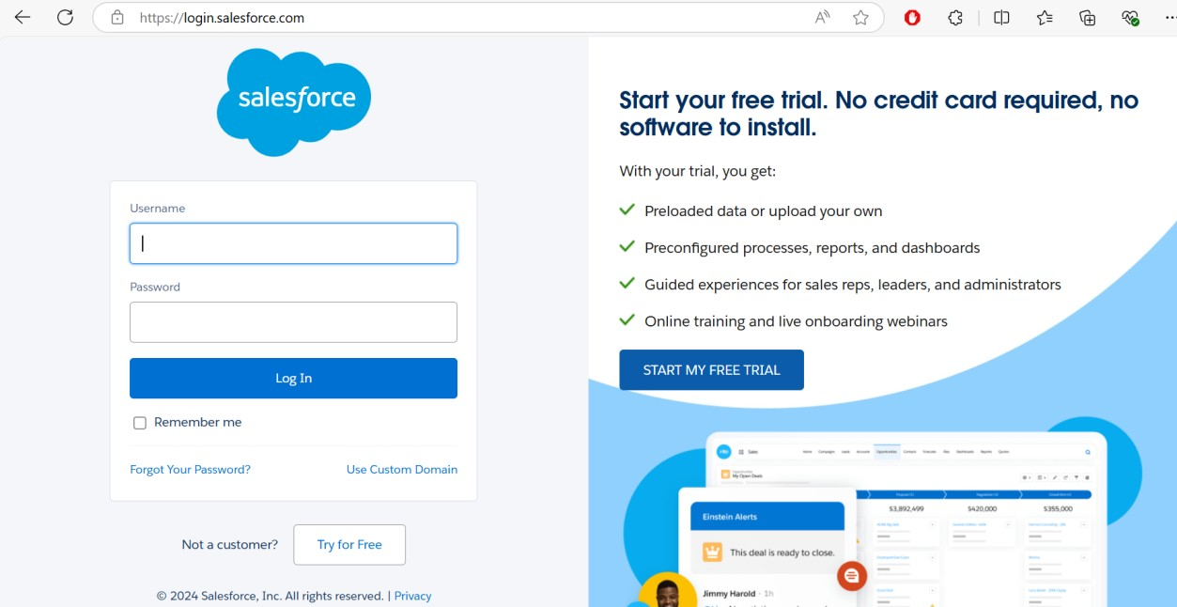

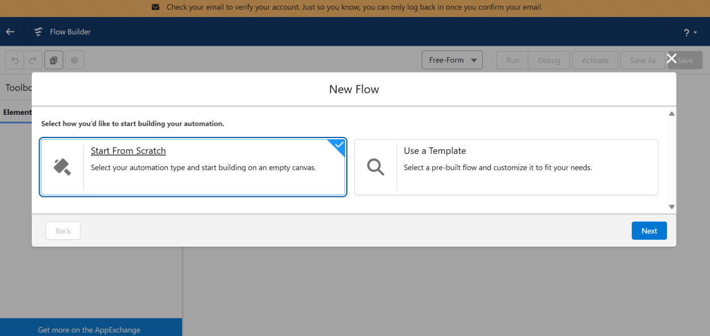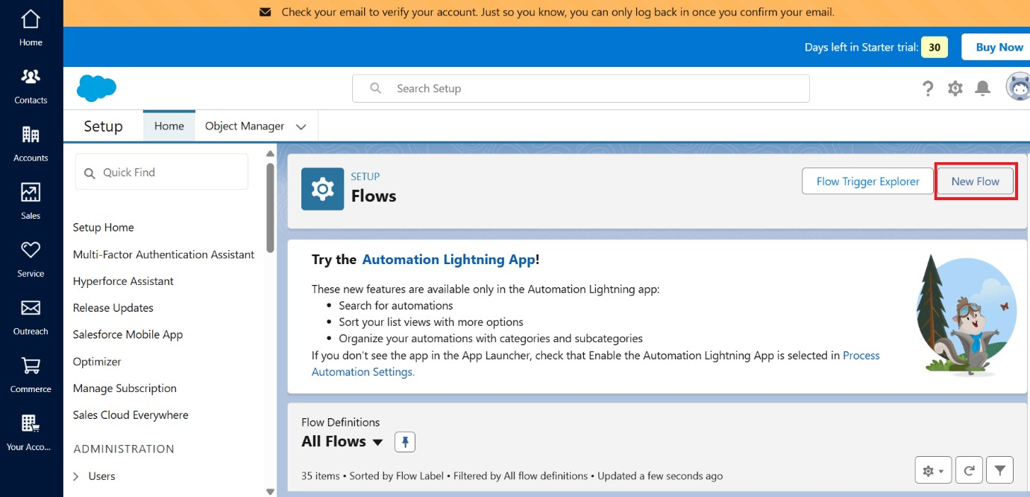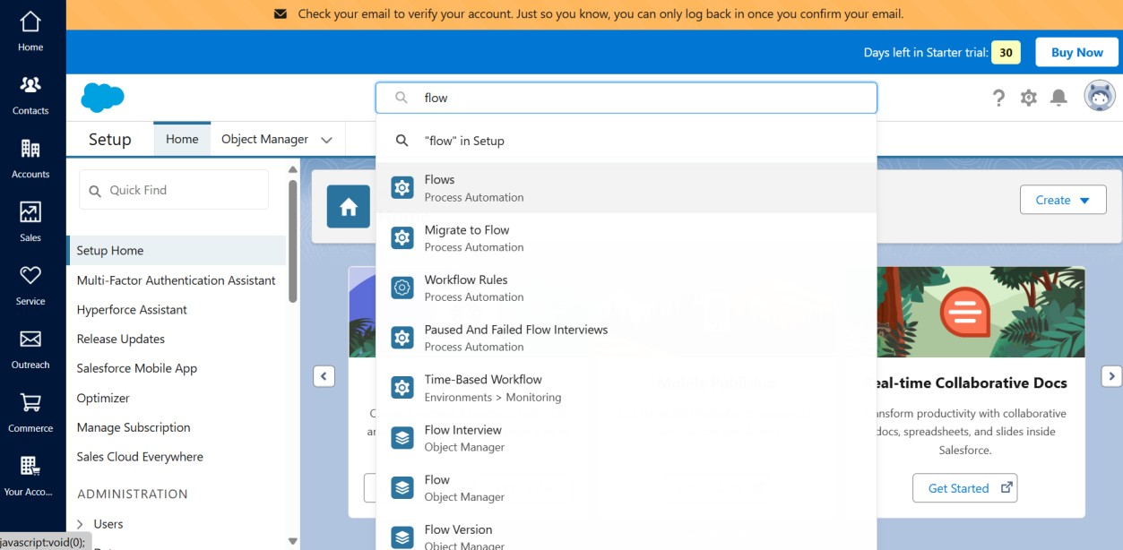

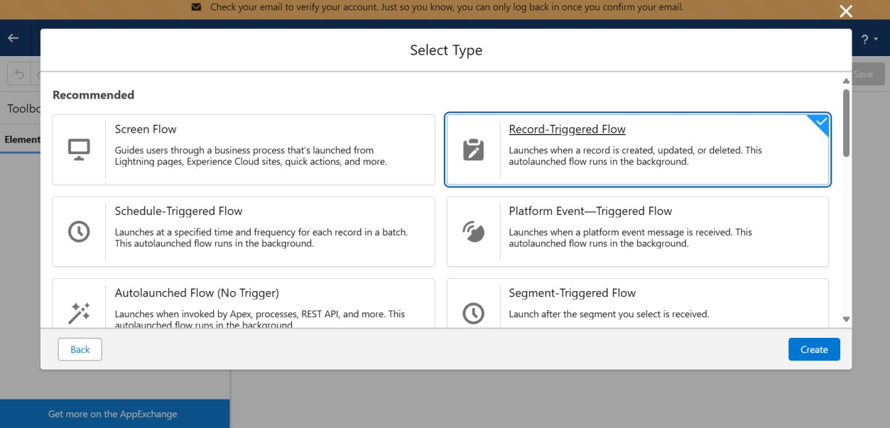

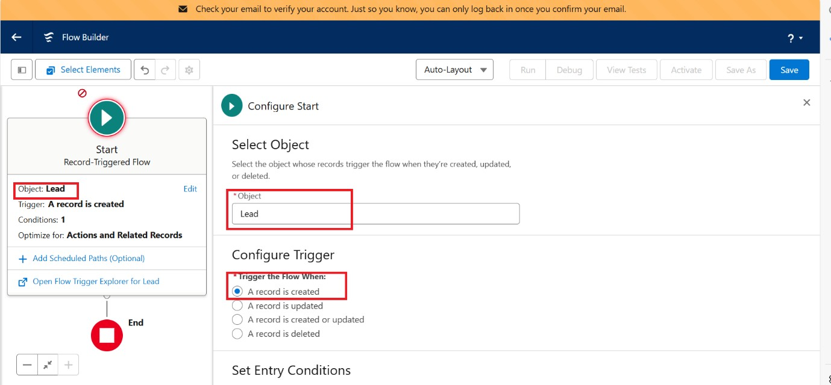

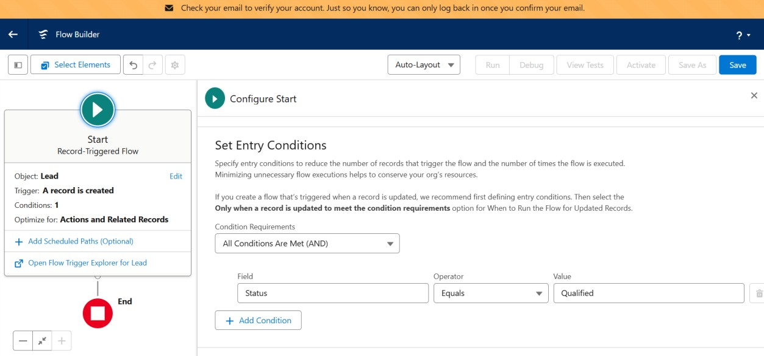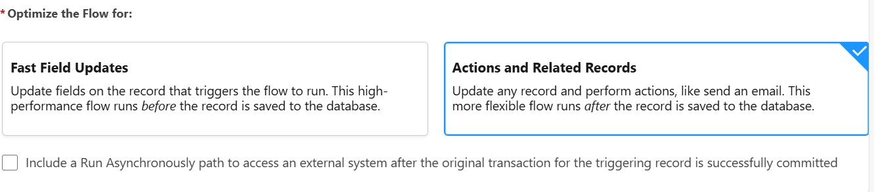

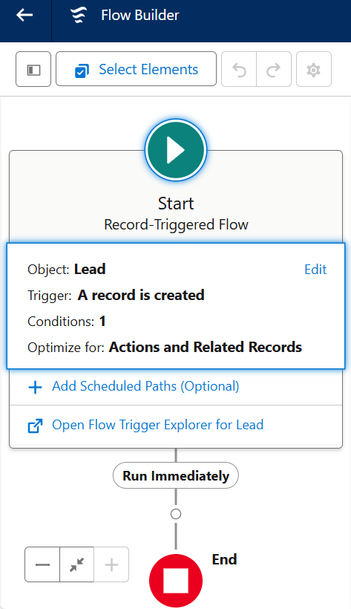

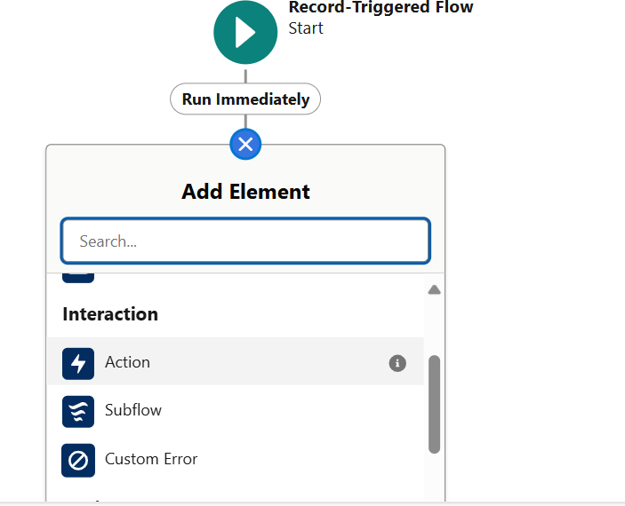

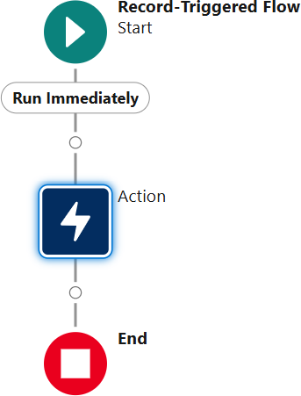

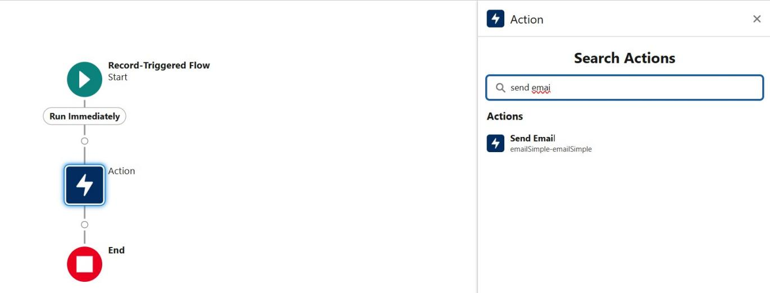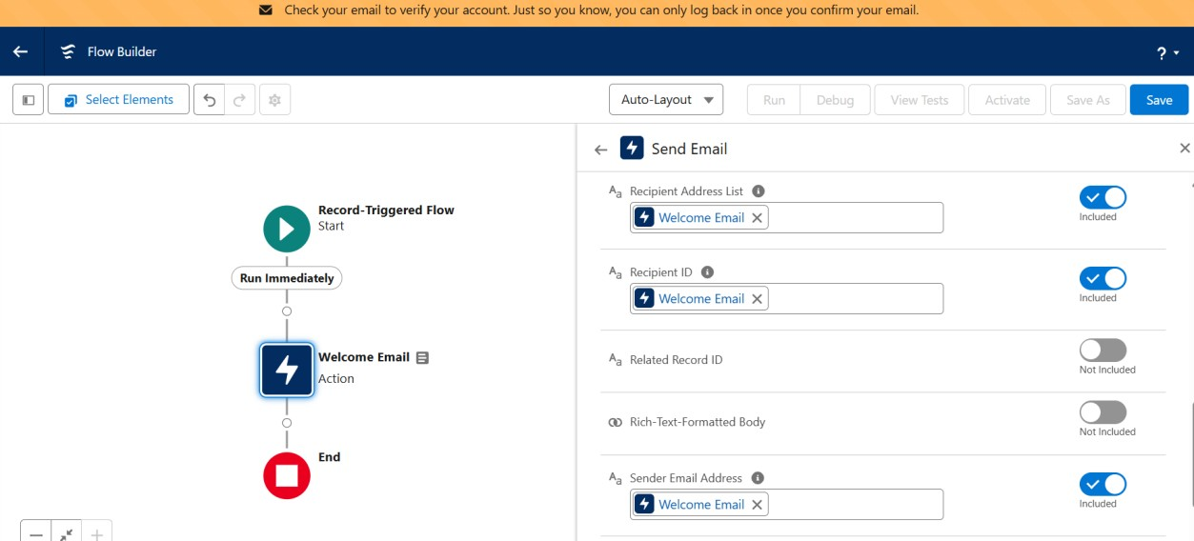

**Result:**

Thus the development of a simple email automation service using salesforce has been executed successfully.